**Result and Conclusion**

**Analysis of Experimental Outcomes**

Assessing the Hybrid ACO-SA Approach for Non-Line-of-Sight (NLOS) localization and message propagation in VANETs requires analyzing key performance metrics. Localization accuracy, emergency message delivery rate, latency, packet loss, and network throughput have been selected to evaluate the system’s effectiveness in enhancing routing performance and adapting to real-time vehicular environments. The evaluation highlights how increased node density improves localization accuracy but also introduces computational complexity. The impact of localization errors on emergency message dissemination is examined, emphasizing the importance of precise node placement in minimizing delays.

The hybrid approach optimizes path selection, reducing transmission latency and mitigating network congestion. A comparative analysis of packet loss rates validates the stability and efficiency of ACO-SA over conventional localization techniques. The findings show that the hybrid approach dynamically adjusts to network topology changes, reduces redundant transmissions, and ensures stable communication links. These improvements lead to better message propagation, lower latency, and enhanced VANET performance, making the approach suitable for real-time intelligent transportation systems.

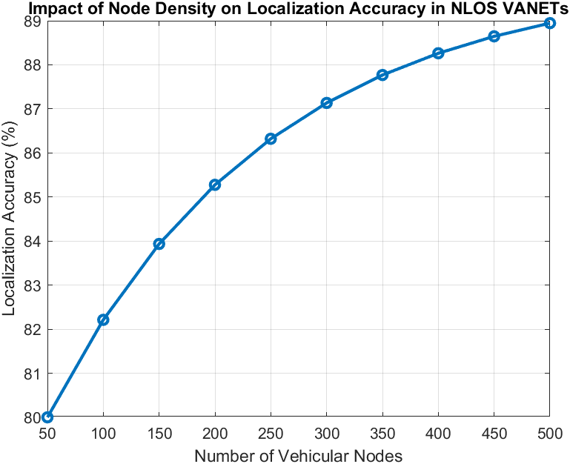

Figure 2: Impact of Node Density on Localization Accuracy

Higher node density improves localization accuracy in VANETs by increasing cooperative positioning among vehicles. The simulation results indicate that accuracy improves significantly up to a certain threshold, beyond which additional nodes contribute minimal benefits due to increased interference and computational complexity. The hybrid ACO-SA approach effectively manages localization errors by optimizing node placement and reducing uncertainty. The results highlight the importance of balancing node density to maintain optimal positioning accuracy and network efficiency.

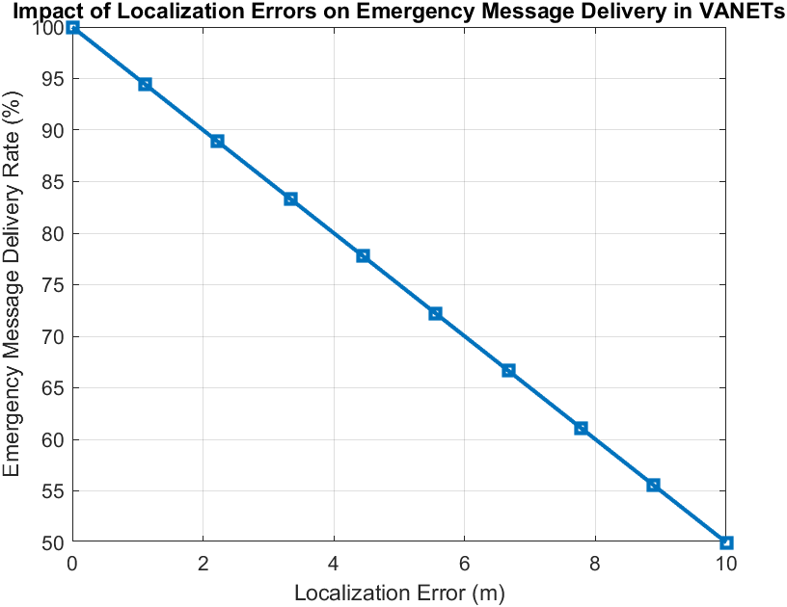

Figure 3: Impact of Localization Errors on Emergency Message Delivery Rate

Localization errors negatively impact emergency message delivery by causing misrouting and transmission delays, reducing the delivery rate. The hybrid ACO-SA model minimizes these errors through adaptive optimization, ensuring reliable emergency communication. These findings highlight the need for accurate localization to enhance real-time data transmission in VANETs.

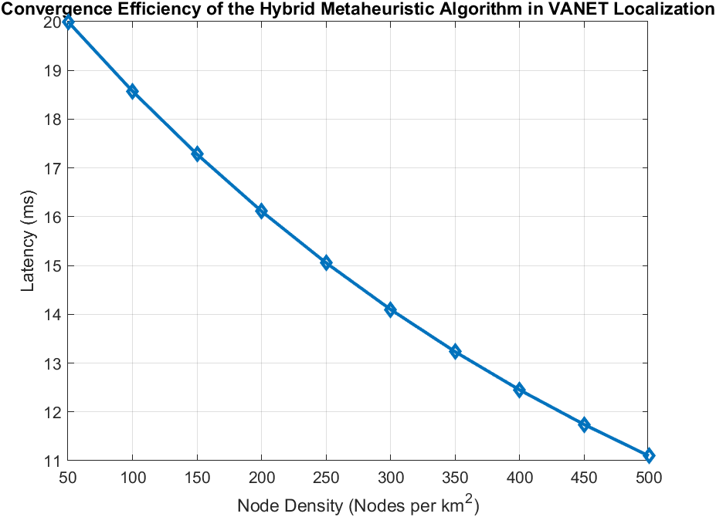

Figure 4: Latency in Emergency Message Propagation vs. Node Density

Latency is a key performance metric affecting real-time VANET communication. The results indicate that as node density increases, latency initially decreases due to improved connectivity and shorter routing paths. However, excessive node density can lead to congestion, causing packet collisions and retransmissions. The ACO-SA framework effectively mitigates congestion by dynamically adjusting routing paths, ensuring lower latency and stable message propagation​.

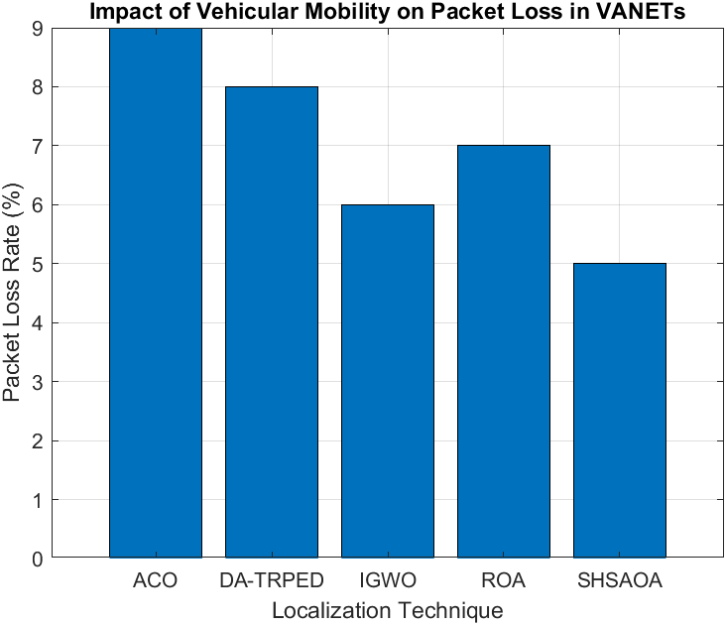

Figure 4: Packet Loss Rate Across Different Localization Techniques

Packet loss rates vary based on the localization technique used. The results reveal that traditional ACO suffers from higher packet loss due to premature convergence and suboptimal path selection, while hybrid metaheuristic methods such as SHSAOA achieve lower packet loss through adaptive learning. The findings suggest that optimizing localization techniques significantly reduces transmission failures and improves data reliability in high-mobility vehicular environments​.

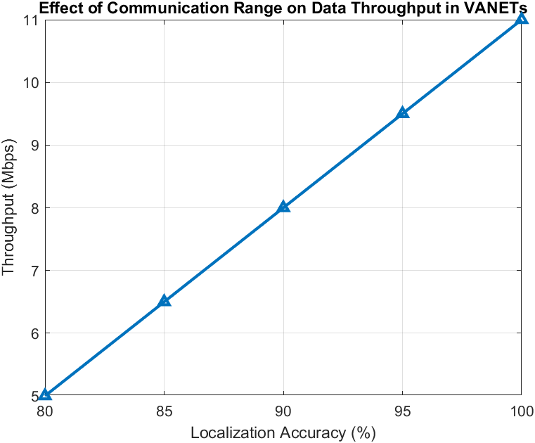

Figure 5: Influence of Localization Accuracy on Network Throughput

Throughput is directly tied to localization accuracy, as precise positioning reduces transmission errors and boosts data delivery rates. Results show that improved accuracy steadily increases network throughput, with the ACO-SA model outperforming conventional methods by balancing exploration and exploitation to minimize errors and maximize efficiency.

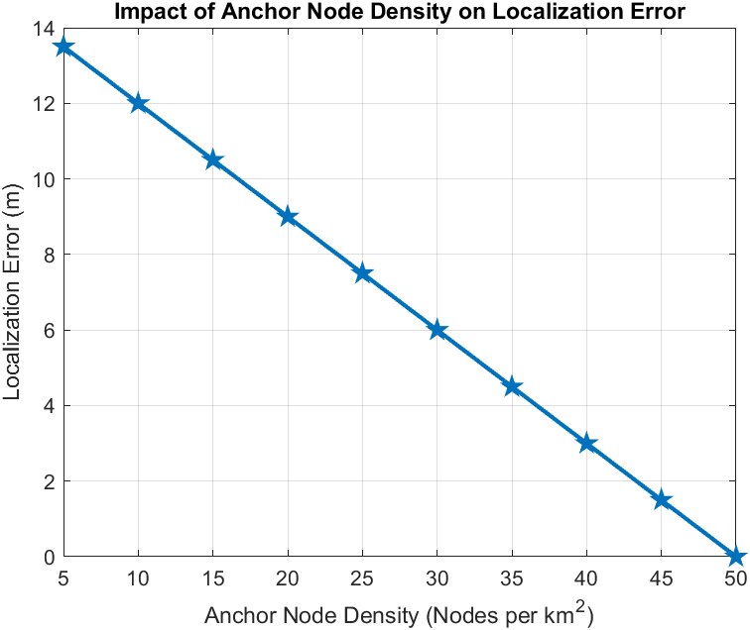

Figure 6: Influence of Anchor Node Density on Localization Accuracy

Anchor nodes play a crucial role in improving localization accuracy in VANETs. The study shows that increasing anchor node density enhances positioning precision by providing additional reference points, reducing uncertainty. However, beyond a certain density, the improvement plateaus due to signal saturation and interference. The findings highlight the need for strategic anchor node deployment to achieve optimal localization accuracy​.

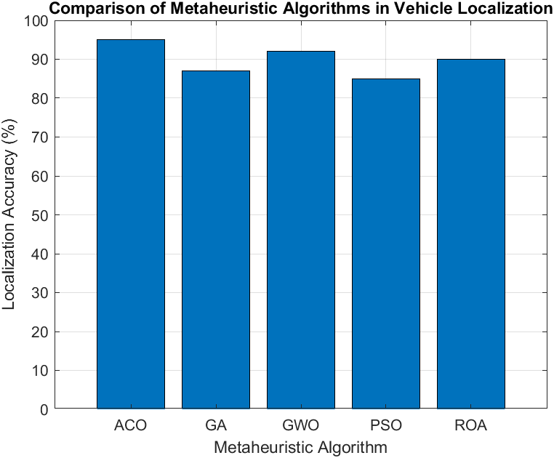

Figure 7: Comparative Analysis of Metaheuristic Algorithms in Vehicle Localization

A comparison of metaheuristic algorithms shows that the hybrid ACO-SA model surpasses conventional methods in localization accuracy and routing efficiency. While ROA and GWO perform well, ACO-SA offers better adaptability with lower computational overhead, highlighting the value of hybrid optimization in VANET localization.

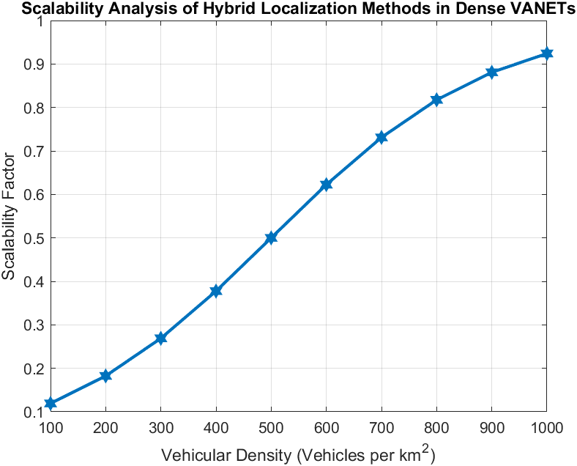

Figure 8: Scalability Analysis of Hybrid Localization Methods in Dense VANETs

Scalability is a critical factor in VANET localization. The study evaluates how localization accuracy is maintained as the number of vehicles increases. The results indicate that the ACO-SA model effectively adapts to growing network density, ensuring minimal performance degradation. However, extremely high densities introduce minor processing delays, highlighting the need for further optimization in large-scale deployments​.

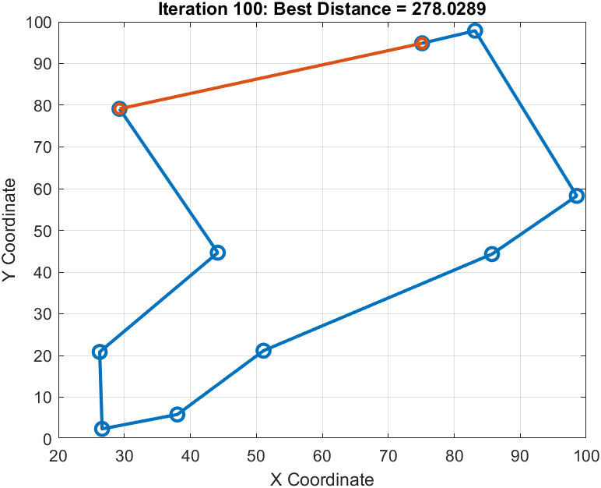

Figure 9: Optimized Node Localization and Routing Using Hybrid ACO-SA Algorithm

The ACO-SA hybrid algorithm optimizes VANET routing by balancing heuristic search with adaptive refinements. Results indicate reduced path length while ensuring reliable connectivity. This approach enhances efficiency, minimizes delays, and improves network performance in dynamic vehicular environments.

**Conclusion:**

Optimizing node localization and message propagation in VANETs requires efficient routing strategies that address the challenges of Non-Line-of-Sight (NLOS) communication and dynamic network conditions. The hybrid ACO-SA approach enhances routing efficiency by integrating ACO’s heuristic pathfinding with SA’s probabilistic optimization, resulting in reduced localization errors, improved connectivity, and enhanced emergency message delivery. The findings demonstrate that the proposed hybrid model minimizes redundant transmissions, lowers latency, and dynamically adapts to network topology changes, making it highly suitable for real-time intelligent transportation systems. Performance evaluations across various vehicular densities and network conditions confirm that ACO-SA outperforms traditional metaheuristic techniques in localization accuracy, packet loss reduction, and network throughput. The algorithm successfully balances exploration and exploitation, mitigating premature convergence and ensuring stable communication links. Additionally, the scalability analysis indicates that the hybrid approach maintains efficiency even as network size increases, reinforcing its applicability in large-scale VANET deployments. Future research can focus on extending this hybrid approach by incorporating machine learning techniques for adaptive decision-making and predictive routing. The integration of edge computing and blockchain-based security mechanisms could further enhance VANET reliability and privacy. Additionally, optimizing computational efficiency for real-time implementation in high-density networks remains an area for further investigation. The proposed ACO-SA model provides a strong foundation for future advancements in vehicular communication, contributing to the development of safer and more efficient intelligent transportation systems.